Real-Time Language Translator
MINI PROJECT REPORT
Submitted in partial fulfilment of the requirements
Third Year for the award of the degree of
Computer Engineering

Done by,
Mayank Anil Sanjay
(Roll no.46)
Kalpesh Vilas Jadhav
(Roll no.17)
Vaibhav Dinesh Marathe
(Roll no.28)

Guide:
Prof. D. S. Tharwani


DEPARTMENT OF COMPUTER ENGINEERING
Konkan Gyaanpeeth College Engineering, Karjat
(Affiliated to Mumbai University, Mumbai)
(2024-2025)

CERTIFICATE

This is to certify the Mini project-2B entitled “Real-Time Language Translator ” is a Bonafide work of Mayank Anil Sanjay-46, Kalpesh Vilas Jadhav-17, Vaibhav Dinesh Marathe-28, submitted to be University of Mumbai in partial fulfilment of the requirement for the award of the degree of “T.E.” in “Computer Engineering”.

Prof. D.S. Tharwani
Guide

Prof. S. M. Patil Dr. V. J. Pillewan
Head of Department Principal

KONKAN GYANPEETH COLLEGE OF ENGINEERING, KARJAT.
(Affiliated to University of Mumbai, Approved by A.I.C.T.E., New Delhi.)
Konkan Gyanpeeth Shaikshanik Sankul, Vengaon Road, Dahivali, Karjat, Dist.-Raigad.410201. (M.S.)
Department of Computer Engineering

Mini-Project-2B Report Approval

This project report entitled “RealTime Language Translator” by “Mayank Anil Sanjay (46), Kalpesh Vilas Jadhav (17), Vaibhav Dinesh Marathe (28)” is approved for the Third Year of Department of Computer Engineering.

Examiners

1..........................................

2..........................................

Date.
Place.

Declaration

We declare that this written submission represents our ideas in my/our own words and where others' ideas or words have been included, we have adequately cited and referenced the original sources. We also declare that We have adhered to all principles of academic honesty and integrity and have not misrepresented or fabricated or falsified any idea/data/fact/source in our submission. We understand that any violation of the above will be cause for disciplinary action by the Institute and can also evoke penal action from the sources which have thus not been properly cited or from whom proper permission has not been taken when needed.

Mayank Anil Sanjay (46) ______________________________________
Kalpesh Vilas Jadhav (17) _____________________________________
Vaibhav Dinesh Marathe (28) ______________________________________

Date:

ACKNOWLEDGEMENT

We are heartily grateful to our project guide Prof. D.S. Tharwani, HOD of Computer department Prof. S.M. Patil, Principal of KGCE, Karjat Dr. V.J. Pillewan for their being a constant source of encouragement at various stages of the completion of this project. We want to thank our parents and lord, because without their blessing, perhaps we could do nothing. We wish to thank all our friends, colleagues and the campus staff (Department of Computer Engineering), who have help us with the critical review of this project including my Friend’s. Their Debugging skills and grateful appreciated.
Special thanks to my Head of the Computer Department Prof. S. M. Patil for his advice and encouragement.
We must thankful to the various Authors who have contributed material for this project.

Mayank Anil Sanjay (46)
Kalpesh Vilas Jadhav (17)
Vaibhav Dinesh Marathe (28)

Real-Time Language Translator
KONKAN GYANPEETH COLLEGE OF ENGINEERING

TABLE OF CONTENTS
1.INTRODUCTION----------------------------------------------------------------------------------------------------------1
1.2 EXISTING SYSTEM------------------------------------------------------------------------------------------------2
1.3 PROBLEM STATEMENT------------------------------------------------------------------------------------------3
1.4 OBJECTIVES---------------------------------------------------------------------------------------------------------4
1.5 SCOPE-----------------------------------------------------------------------------------------------------------------5
1.6 PROPOSED SYSTEM-----------------------------------------------------------------------------------------------6
2.REVIEW OF LITERATURE----------------------------------------------------------------------------------------------8

3. SYSTEM SPECIFICATION---------------------------------------------------------------------------------------------10
3.1 SOFTWARE SPECIFICATION----------------------------------------------------------------------------------11
3.2 HARDWARE SPECIFICATION---------------------------------------------------------------------------------11
4.SYSTEM DESIGN---------------------------------------------------------------------------------------------------------12
5. FUTURE SCOPES---------------------------------------------------------------------------------------------------------15
6. CODE -----------------------------------------------------------------------------------------------------------------------17
7. RESULT---------------------------------------------------------------------------------------------------------------------21

ABSTRACT

In this project, we aim to design and implement a Real-time language translator using Python. In an increasingly globalized world, effective communication across language barriers has become essential. This project presents the development of a Real-Time Language Translator, a system designed to facilitate seamless, instant translation between multiple languages in spoken or textual form. The translator utilizes advanced speech recognition, natural language processing (NLP), and text-to-speech technologies to convert input speech or text from one language into another in real time. The system is built using a combination of APIs and machine learning models that ensure high accuracy and low latency. Key features include multi-language support, voice and adaptability for mobile and web platforms. This project aims to enhance cross-cultural communication in areas such as travel, business, healthcare, and education, making interactions more accessible and inclusive.

Chapter no.1
INTRODUCTION

Real-Time Language Translator

1.1. INTRODUCTION

Language is one of the most powerful tools for human communication, yet it often becomes a barrier when people from different linguistic backgrounds interact. With globalization and the rise of international collaboration in fields such as business, travel, healthcare, and education, the need for efficient and reliable language translation has grown significantly. Traditional translation methods, such as dictionaries or manual interpretation, are time-consuming and not always feasible in fast-paced, real-world scenarios.
This project focuses on the design and development of a Real-Time Language Translator that enables instant translation of speech or text between multiple languages. By integrating modern technologies such as speech recognition, machine translation, natural language processing (NLP), and text-to-speech synthesis, the system provides users with a seamless communication experience across linguistic boundaries.
The main objective is to create an application that can accurately and quickly translate spoken or written language in real time, ensuring that communication remains natural and fluid. The system is intended to be user-friendly, platform-independent, and scalable, making it suitable for everyday use in diverse environments, from casual conversations to professional settings.

1.2 Existing System

Several real-time language translation systems currently exist, including Google Translate, Microsoft Translator, iTranslate, and SayHi, each offering features like speech-to-text, voice translation, and multi-language support. These tools leverage cloud-based services and AI technologies to facilitate communication across language barriers. While widely used, they often rely heavily on internet connectivity, may struggle with context-specific accuracy, and offer limited offline functionality. Additionally, some systems come with usage restrictions, subscription requirements, or privacy concerns due to data being processed on external servers. Despite their usefulness, there remains a need for more customizable, accurate, and offline-capable solutions.

1.3 Problem Statement

In today’s globalized world, effective communication between people who speak different languages remains a significant challenge. Existing translation tools often rely on constant internet connectivity, struggle with real-time processing, and lack contextual accuracy in conversations. Additionally, many of these systems are not optimized for offline use or tailored for specific user needs, such as in healthcare, travel, or education. There is a need for a reliable, fast, and user-friendly real-time language translator that can provide accurate speech and text translation across multiple languages, even in environments with limited connectivity.
This problem statement encompasses several key challenges that need to be addressed:
- Most existing systems require a stable internet connection to function accurately.

- Contextual and conversational accuracy is often lacking, especially in informal or complex sentences.

- Offline translation support is limited or only available for a few languages.

- Many tools are not customizable for specific domains (e.g., medical, legal, or technical language).

- Privacy concerns arise due to the use of cloud-based services that process personal conversations.
- High subscription costs or usage limitations restrict accessibility for all users.

There is a need for a more robust, real-time translation system that is accurate, context-aware, accessible offline, and adaptable to various user needs.

1.4 Objectives

Objectives for Chatbot is as follows:-
The main objective of this project is to develop a real-time language translation system that facilitates smooth and accurate communication between speakers of different languages. The specific objectives are:
- To design a system that translates speech and text in real time across multiple languages.

- To integrate speech recognition and text-to-speech modules for a natural conversational experience.

- To achieve high translation accuracy with proper context understanding and minimal latency.

- To provide offline translation capability for use in areas with poor or no internet connectivity.

- To build a user-friendly interface that can be easily used by people with little to no technical background.

- To ensure data privacy and security during translation processes.

- To make the system scalable and adaptable for adding more languages or domain-specific vocabularies.

1.5 SCOPE

The Real-Time Language Translator project aims to develop an application capable of translating spoken and written language instantly between multiple languages. The system will focus on integrating speech recognition, machine translation, and text-to-speech technologies to enable smooth and natural communication in real time. It will support both text and voice inputs and provide outputs in audio and/or text form, depending on user preference.
The project will initially support a selected set of widely spoken languages, with provisions to expand support in the future. It will be designed to function efficiently in environments with both internet and limited connectivity, offering offline capabilities for basic translation tasks. The translator will be optimized for use in practical scenarios such as travel, education, healthcare, and customer service. Additionally, the system will emphasize user-friendly interface design, translation accuracy, response speed, and data privacy.
However, the scope does not include advanced AI features like emotion detection, sarcasm understanding, or deep cultural context translation in this initial phase. Also, regional dialects and less common languages may not be supported in the early versions.

1.6 PROPOSED SYSTEM

The proposed system for the Real-Time Language Translator aims to provide users with seamless communication by offering instant translation of speech in real time. It will integrate technologies such as speech recognition, machine translation accurately translate spoken or written content between multiple languages. The system will support bidirectional translation, allowing users to communicate naturally in both directions, making it ideal for applications in areas such as travel, business, healthcare, and education. The initial version of the system will support several widely spoken languages, with plans for future scalability to include more languages and regional dialects.
The system will be designed for use in online environment, ensuring accessibility even in areas with limited internet connectivity. The real-time translation engine will rely on cloud-based APIs for high-quality translations. The user interface will be intuitive and accessible on both mobile and desktop platforms, with a focus on ease of use. Additionally, the system will prioritize data privacy and security, processing sensitive user information locally when possible. This comprehensive system will offer a robust solution to bridge language barriers in real-time, promoting cross-cultural communication and collaboration.

Chapter no. 2
REVIEW OF LITERATURE

2.Review of literature

Real-time language translation systems have gained significant momentum with the integration of artificial intelligence (AI), machine learning (ML), and natural language processing (NLP) techniques. Siddhi Divate, Gajashree Biradar, Amruta Patole, and Nikat Attar (2023), in their paper published in the International Research Journal of Modernization in Engineering Technology and Science, highlight the importance of developing accurate and user-friendly translators that use AI for real-time speech and text conversion. They emphasize cloud-based APIs for expanded language support, although they acknowledge issues related to internet dependency. Similarly, Darshan Shilvant, Ejaz Sayyed, Sarang Jagdale, and Prof. Rachika Waghmare (2024), in the IJARSCT, present a model that leverages deep learning for speech-to-text and text-to-speech functionalities, while also addressing the limitations in translating idiomatic language and handling diverse dialects. A preprint titled Real-Time Language Translation Using AI and ML (EasyChair, 2023) explores system architecture in more detail, comparing models like sequence-to-sequence and transformer-based networks for their efficiency in real-time applications. M. Vaishnavi, H.R. Dhanush Datta, Varsha Vemuri, and L. Jahnavi introduce a language translation application focused on creating an intuitive mobile interface while integrating widely available APIs such as Google Translate, making the system accessible to non-technical users. Another important contribution is by Monika BK, Arun Kumar, Nisha HV, and Susheel Kumar PM (2024), published in the International Journal of Research Publication and Reviews, which evaluates the role of diverse datasets and model training techniques in enhancing translation accuracy, particularly in speech synthesis and tonal clarity. Collectively, these studies show substantial progress in the development of real-time translation systems, yet they also reveal persistent challenges in contextual understanding, offline functionality, and optimization for resource-constrained environments. The current project aims to bridge these gaps by developing a lightweight, efficient, and accurate translation system that can perform reliably across different devices and settings.

S.R. NO. | Title | Author | Summary | Scope
1. | Real Time Voice Translator | Darshan Shilvant, Ejaz Sayyed, Sarang Jagdale, Prof. Rachika Waghmare | This study focuses on the development of a real-time voice translator that converts spoken language into another language instantly. The system aims to assist individuals in overcoming language barriers during verbal communication. | The scope includes the design and implementation of a real-time voice translation system, targeting applications in scenarios where immediate verbal translation is required
2. | Real Time Language Translation Using AI and ML | Prudhvi Sandeep Varma Pamudhurthy, Rajesh Komali | This paper provides a comprehensive overview of real-time language translation using artificial intelligence (AI) and machine learning (ML) techniques | The scope covers the exploration of AI and ML methodologies applied to real-time language translation.
3. | Real Time Language Translator | Siddhi Divate, Gajashree Biradar, Amruta Patole, Nikat Attar | This paper presents a real-time language translator system that facilitates seamless communication across different languages. | The scope encompasses the development and analysis of a real-time language translation system, exploring various translation methodologies and their applications.

Chapter no. 3
SYSTEM SPECIFICATION

3. SYSTEM SPECIFICATION
User Interaction: NLP for understanding queries and multi-turn conversations.
Information Retrieval: Access to a knowledge base.
Personalization: Adapt responses based on user history.
Integration: Connect with existing systems (e.g., CRM).

3.1. SOFTWARE REQUIREMENTS

Operating System: Linux (Ubuntu preferred) or Windows.
Programming Languages: Python (for machine learning and API integrations).
Libraries: Gradio (for the interface), AssemblyAI (for transcription), ElevenLabs (for TTS), and Translator library (for translations).
API Keys: AssemblyAI and ElevenLabs API keys (managed via environment variables).

3.2. HARDWARE SPECIFICATION

Processor Intel Pentium or above.
Hard Disc 128GB.
Display Type PC Display
Keyboard PC/AT Enhanced PS/2Keyboard
Mouse First/Pilot Mouse Serial (c48).
Input Device Mouse, keyboard
Output Device Monitor, Mobile Display

Chapter no.4
SYSTEM DESIGN
4.1 DATA FLOW DIAGRAMS

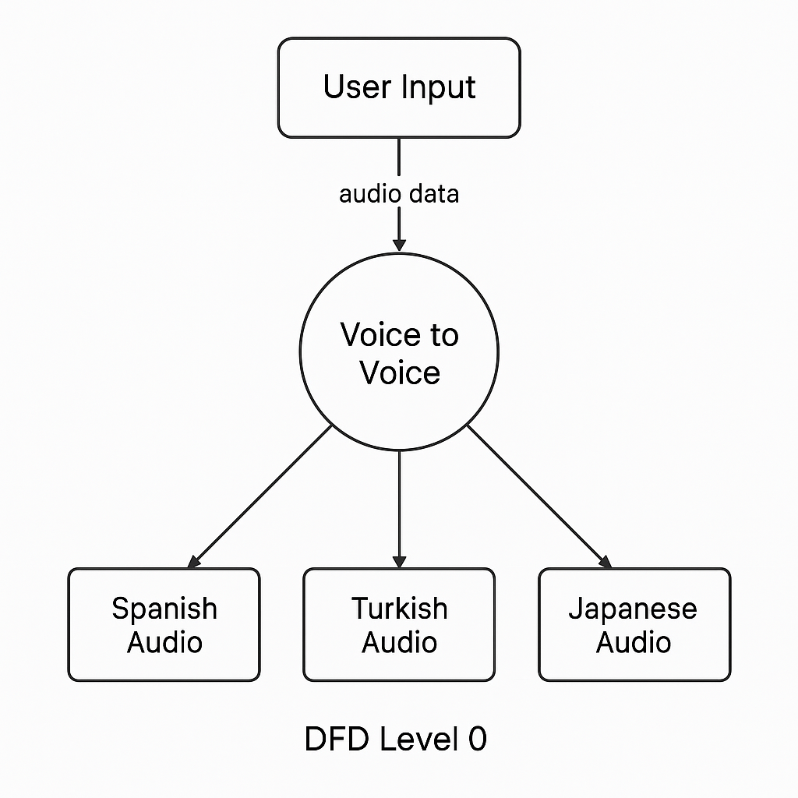
Fig. : DFD Level 0

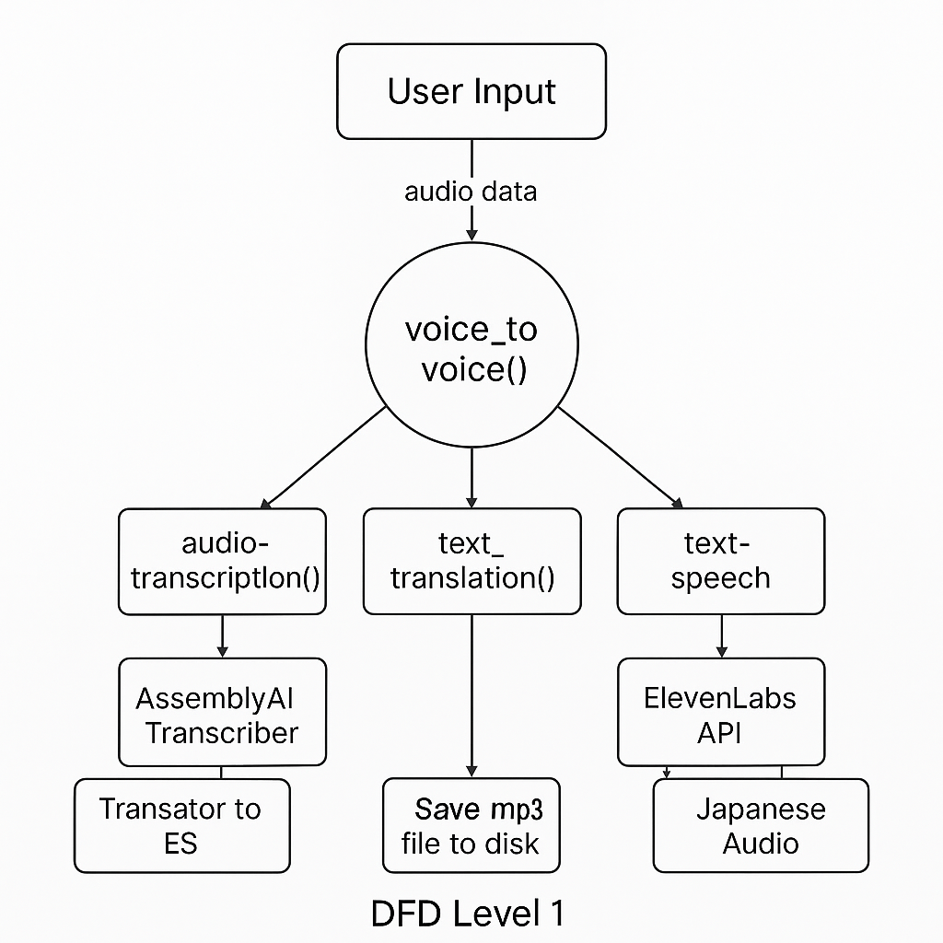
Fig. : DFD Level 1

Chapter no.5
Future Scopes

5.Future scopes

The future scope of the Real-Time Language Translator is vast, with numerous opportunities for expansion and improvement. Some key areas for future development include:
- Expansion of Language Support: As global connectivity increases, the translator can be expanded to support more languages and dialects, including less widely spoken and regional languages. The addition of specialized vocabularies for technical fields like medicine, law, and engineering will enhance the system’s applicability in professional settings.
- Improved Offline Functionality: Currently, many translation tools rely on cloud services, limiting their functionality in offline scenarios. Future versions could incorporate more advanced offline translation models that allow for higher-quality, real-time translations without internet connectivity, even in remote areas.
- Contextual and Cultural Awareness: Advancements in context-aware translation could significantly improve the system’s ability to understand idiomatic expressions, slang, and cultural nuances. This would make translations more natural and accurate, especially in real-time conversational settings.
- Multimodal Translation: The integration of visual input (such as image and video translation) could allow the system to recognize text in pictures or translate signs and documents in real-time, broadening its application in travel, business, and education.
- Enhanced Privacy and Security: With growing concerns over data privacy, future iterations can include edge computing to process translations locally on users' devices, reducing reliance on cloud storage and enhancing data security. End-to-end encryption could further ensure the privacy of sensitive conversations.
- AI-Powered Personalization: The system could integrate machine learning algorithms to adapt to individual users’ speaking styles, accents, and preferences, resulting in more accurate translations tailored to specific communication needs.
These advancements would not only enhance the system’s accuracy and efficiency but also make it a more versatile tool across a variety of industries and use cases, further breaking down communication barriers worldwide.

GANTT CHART

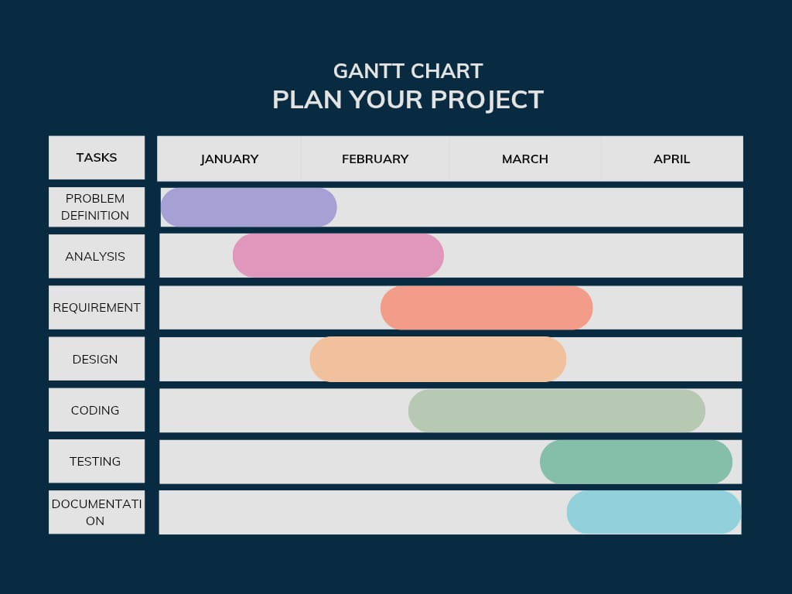

Chapter no.6
SOURCE CODE

6.SOURCE CODE

import gradio as gr
import assemblyai as aai
from translate import Translator
from elevenlabs import VoiceSettings
from elevenlabs.client import ElevenLabs
import uuid
from pathlib import Path
import package_name

def voice_to_voice(audio_file):

#transcribe audio
transcription_response = audio_transcription(audio_file)

if transcription_response.status == aai.TranscriptStatus.error:
raise gr.Error(transcription_response.error)
else:
text = transcription_response.text

es_translation, tr_translation, ja_translation = text_translation(text)

es_audi_path = text_to_speech(es_translation)
tr_audi_path = text_to_speech(tr_translation)
ja_audi_path = text_to_speech(ja_translation)

es_path = Path(es_audi_path)
tr_path = Path(tr_audi_path)
ja_path = Path(ja_audi_path)

return es_path, tr_path, ja_path

def audio_transcription(audio_file):

aai.settings.api_key = "35ae5ac3080b43e2b47d76e4a33cc53e"

transcriber = aai.Transcriber()
transcription = transcriber.transcribe(audio_file)

return transcription

def text_translation(text):

translator_es = Translator(from_lang="en", to_lang="es")
es_text = translator_es.translate(text)

translator_tr = Translator(from_lang="en", to_lang="tr")
tr_text = translator_tr.translate(text)

translator_ja = Translator(from_lang="en", to_lang="ja")
ja_text = translator_ja.translate(text)

return es_text, tr_text, ja_text

def text_to_speech(text):

client = ElevenLabs(
api_key= "sk_59b115106561318fc5f5bb721438c386f23f2b2053c667e7",
)

# Calling the text_to_speech conversion API with detailed parameters
response = client.text_to_speech.convert(
voice_id="pMsXgVXv3BLzUgSXRplE", #clone your voice on elevenlabs dashboard and copy the id
optimize_streaming_latency="0",
output_format="mp3_22050_32",
text=text,
model_id="eleven_multilingual_v2", # use the turbo model for low latency, for other languages use the eleven_multilingual_v2
voice_settings=VoiceSettings(
stability=0.5,
similarity_boost=0.8,
style=0.5,
use_speaker_boost=True,
),
)

# Generating a unique file name for the output MP3 file
save_file_path = f"{uuid.uuid4()}.mp3"

# Writing the audio to a file
with open(save_file_path, "wb") as f:
for chunk in response:
if chunk:
f.write(chunk)

print(f"{save_file_path}: A new audio file was saved successfully!")

# Return the path of the saved audio file
return save_file_path

audio_input = gr.Audio(
sources=["microphone"],
type="filepath"
)
demo = gr.Interface(
fn=voice_to_voice,
inputs=audio_input,
outputs=[gr.Audio(label="Spanish"), gr.Audio(label="Turkish"), gr.Audio(label="Japanese")]
)
if _name_ == "_main_":
demo.launch()

Chapter no. 7
RESULT

7.RESULT

Output :

7.1 IMPLEMENTATION

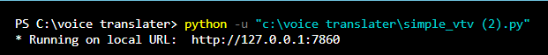

7.2 RESPONSE

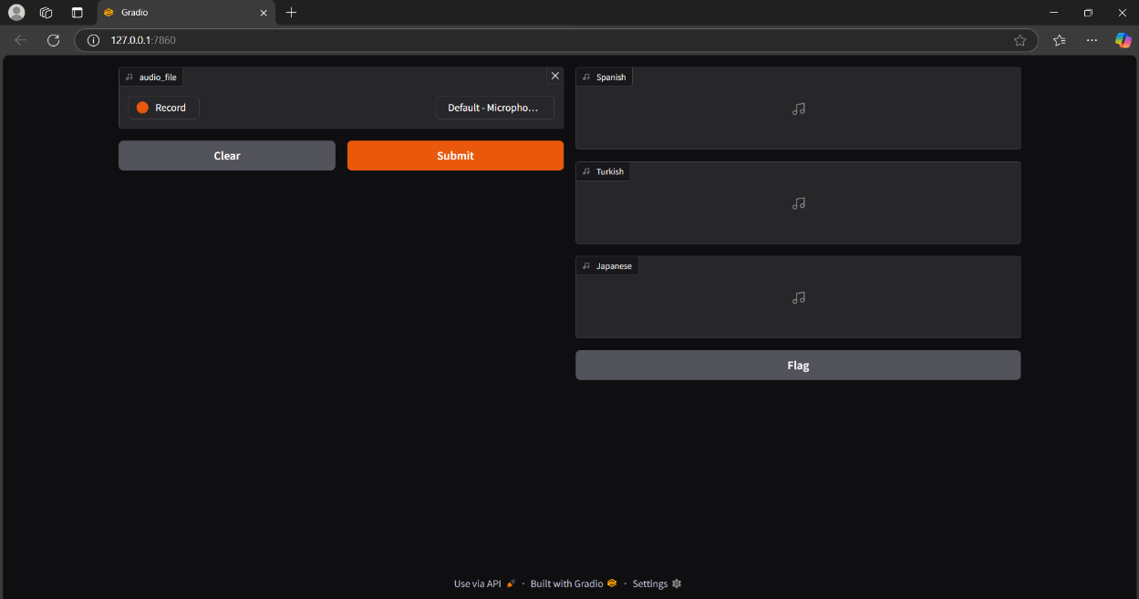

7.3 TRANSLATED AUDIO

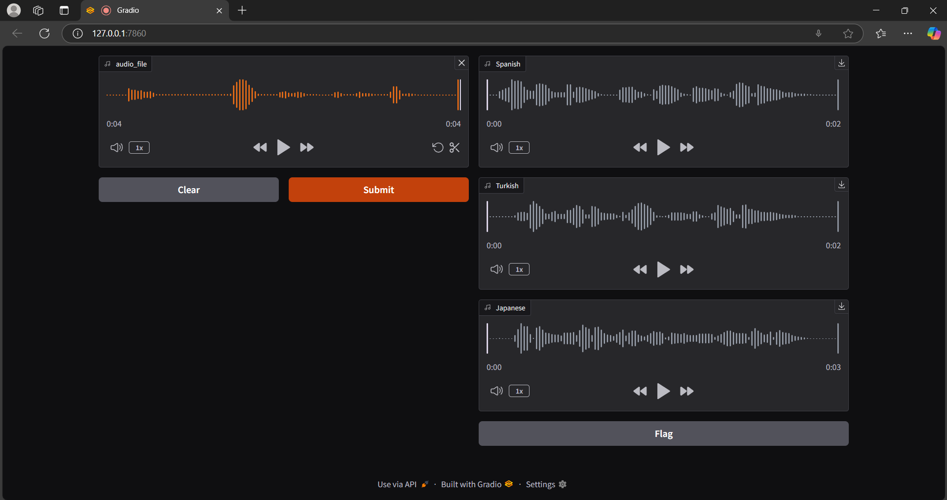

CONCLUSION

The development of a Real-Time Language Translator holds immense potential in overcoming language barriers, fostering global communication, and improving interactions in diverse fields such as travel, healthcare, business, and education. By leveraging cutting-edge technologies like speech recognition, neural machine translation, and text-to-speech synthesis, the proposed system aims to provide accurate, context-aware translations in real time. While existing systems offer useful features, challenges such as offline functionality, privacy concerns, and contextual accuracy remain prevalent.
This project addresses these challenges by focusing on a multi-language, user-friendly platform with both online and offline capabilities, while prioritizing data security. As the system evolves, its future scope will include expanding language support, improving contextual understanding, and enhancing privacy measures. Ultimately, the real-time language translator will provide a scalable and adaptive solution to break down communication barriers and enable seamless interactions across cultures and industries.

REFERENCE

- International Research Journal of Modernization in Engineering Technology and Science Volume:05/Issue:12/December-2023 Siddhi Divate*1, Gajashree Biradar*2, Amruta Patole*3, Nikat Attar*4
- IJARSCT Volume 4, Issue 1, April 2024 Darshan Shilvant1 , Ejaz Sayyed2 , Sarang Jagdale3 , Prof. Rachika Waghmare4
- Real Time Language Translation Using AI and ML https://easychair.org/publications/preprint/jjqv
- Language Translator Application Authors: M Vaishnavi, HR Dhanush Datta, Varsha Vemuri, L Jahnavi
- International Journal of Research Publication and Reviews, Vol 5, no 1, pp 2084-2088 January 2024 Monika BK, Arun Kumar, Nisha HV, Susheel Kumar PM

